Archived News Articles:

No Sump Pump Discharge After April 1st
(April 2022)

PLSD Ordinance 13 allows sump pumps to discharge into the sanitary sewer system November 1 – April 1. Customers in need of sump pumps over the winter months should move their sump pump discharge hoses to the outside by April 1st. Springtime ground water taxes the sewer system, so complying with the April 1st deadline helps alleviate additional burden on the system. PLSD reminds you that you must complete a sump pump permit as required by the ordinance. You can find the permit form on our website.

Notice of Public Hearing
(November 2021)
The Pickerel Lake Sanitary District is seeking $2,963,000 of funding from the Board of Agriculture and Natural Resources for replacement and rehabilitation of 13 main lift stations and expanding the current wastewater system. The funds could be either a grant from the state Consolidated Water Facilities Construction Program or a loan from the Clean Water State Revolving Fund (SRF) Program. The Clean Water SRF loan terms are 2.125% for 30 years, and the Board of Agriculture and Natural Resources may forgive all or a portion of loan principal. The amount, source of funds, and terms will be determined by the Board of Agriculture and Natural Resources when the application is presented at a scheduled board meeting. The purpose of the public hearing is to discuss the proposed project, the proposed financing, and the source of repayment for the loan. The public is invited to attend and comment on the project.

The public hearing will be held at the Pickerel Lake Sanitary District Office at 2908 Peabody Ave, Grenville, SD on November 16, 2021, at 4:00 pm.

PLSD Updates Ordinance 12A
(July 2021)

The PLSD Board researched comparable municipalities that operate sanitary sewer systems to determine customer responsibilities for maintaining system components that exist on their property. Based on the research, customers are typically responsible for any components that are on their property that connect their structure to the main collection line. This includes all pipe, septic tanks, receptacles, lift pumps, control boxes, and other accessories. The main line and equipment necessary to operate the system is maintained by the sanitary district. As a result of these findings, the Board proceeded with amending Ordinance 12A to move financial responsibility to the customer for repairs completed on the owner’s property. PLSD will work with cabin owners to facilitate timely repairs. The amended ordinance will become effective August 9, 2021.

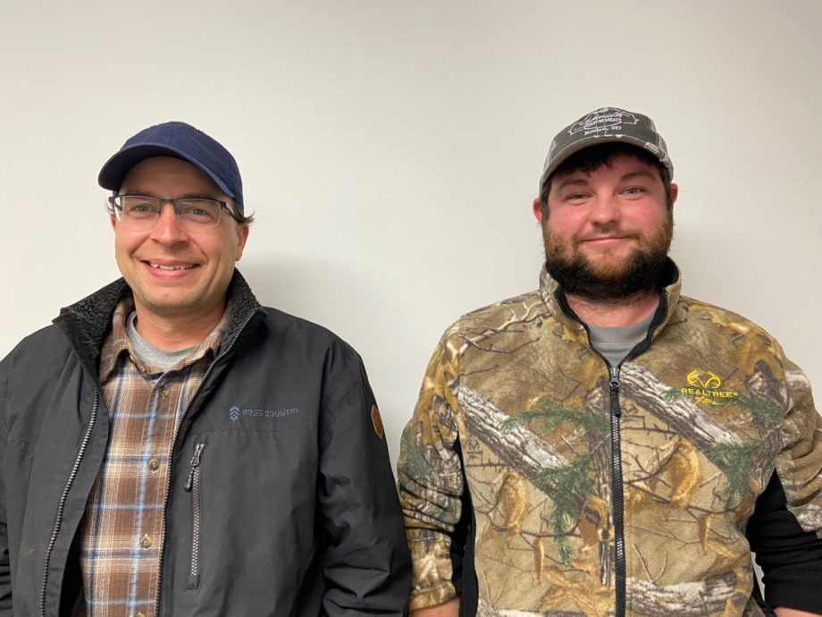

PLSD Hires Justin Carlson and Curtis Gruba
(December 2020)

The PLSD Board promoted Justin Carlson (right) to System Manager effective December 1, 2020. Justin has extensive experience with managing wastewater systems, is certified, and is already familiar with the PLSD system from serving in the backup maintenance position. He will be a great asset to the District and is actively evaluating the system to prioritize the next phase of system improvements. Justin is married with a daughter and lives outside of Roslyn. Please welcome Justin as he gets to know all the PLSD customers over the coming months. The Board hired Curtis Gruba (left) to replace Justin as the backup maintenance employee effective January 1, 2021.

The Board also recognizes Al Fedje for his years of service with PLSD and wish him the best in his future plans.

Aquatic Invasive Species Found
(August 2020)
Unfortunately, the zebra mussel has made its way to our lake. The GF&P announced the discovery in July. The PLSD is closely following the development and will work with the GF&P to help educate our cabin owners. The GF&P includes the zebra mussel on its SD Least Wanted website and shares a publication on the topic. The Pickerel Lake Conservancy website also contains detailed information about the current aquatic invasive species found at the lake. We’ll continue to post additional information as it becomes known.

PLSD Keeps Rates Low
(January 2020)

PLSD is pleased to announce that 2021 rates will not increase. The Board is required to periodically review customer rates to ensure revenue is adequate to cover anticipated operating expenses and system reserve funds. Beginning with 2021, the $50 capital improvement fee ends; however, the amount will be allocated to the operating and reserve funds as follows:

Fee Amount Yearly Total
Operating Expense $205.48 $410.96
Reserve & Replacement $68.92 $137.84
Total $274.40 $548.80

You will receive your spring billing by March 1st, due March 31st, and your fall billing by September 1st; due September 30th.

PLSD Completes Line Inspection
(November 2019)

In 2019, the Board consulted with the wastewater division of the South Dakota Association of Rural Water Systems (SDARWS) to complete camera work on the gravity lines of the system. The initial work by Hydro-Klean commenced in June with line pressure cleaning followed by camera inspection. Based on the inspection, manhole rehabilitation was completed on certain manholes in Spring 2020. Additional manhole rehabilitation may be completed in 2020 or 2021. The District is proactively making an assessment of the sanitary sewer system as part of the overall maintenance to ensure the integrity of a long-term system.

PLSD Alert System Implemented
(June 2019)

PLSD implemented an alert system this past winter and tested it on May 22, 2019. The system will allow the District to contact cabin owners when the sanitary system is down for repairs or not operating due to a power outage. The system will send out a text message to the cabin owner's cell phone. The District needs a primary cell number for each cabin and has secured the majority of the numbers. If you didn’t receive a test text message on May 22nd and would like to be included, send your name and primary cell number to the District's email: info@plsdistrict.org

Septic Tanks - Resources
(June 2018)
As cabin owners, you are responsible for maintaining a healthy septic system to ensure your system works properly. Here are some resources you can check out to learn more about your septic system and how to maintain a healthy environment.
​
- SepticSmart Homeowners (EPA.gov)
  - How your septic system works
  - How to care for your septic system
  - Think at the Sink!
  - Protect your pipes!​
- Maintaining Your Septic System - Best Practices​ (PIPELINE – Fall 2004; Vol.15, No. 4)

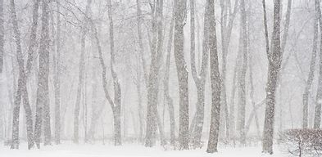

Winter - PLSD is Ready!
(December 2017)

PLSD installed a permanent generator at the main lift station at the South End and purchased a portable generator for the service truck to run the pumps as needed.

So, PLSD is ready, are you? Whether you’re a fulltime lake resident or just a summer visitor, there are steps you should take to safeguard your place from damage caused by power outages. Lake Region Electric and Ottertail Power Company have storm center resources on their websites. LREA also maintains a live outage map. Tips for snowbirds can be found on the internet and to learn more about generator safety, visit Energy.gov.

Sewer Odor?
(June 2016)

If you detect sewer odor outside your cabin, consider installing a carbon filter on your sewer vent pipe. PLSD does not endorse any specific brand; however, one example can be found on www.odorhog.com. PLSD does not install the filters nor are they responsible for maintaining them; however, many cabin owners have found improvement by installing this type of filter.

